**Data Analytics SQL Mini-Project**

**Insight number 1:-Total number of cars present in dataset ?**

select count(name) from CARS2_CARDATASET;

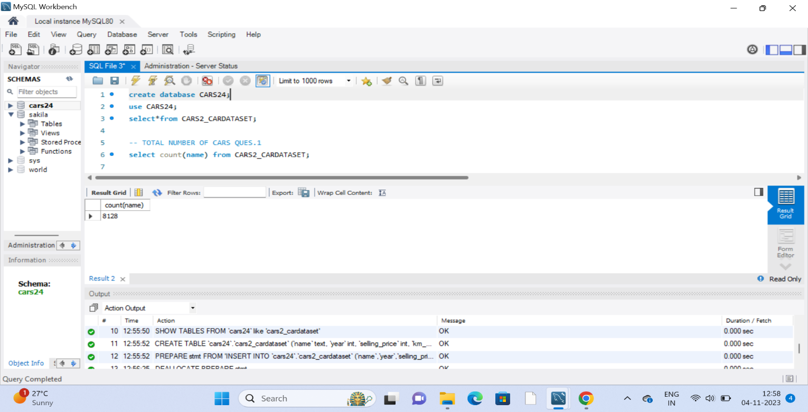

**Insight number 2:-Top 10 most expensive cars on the bases of price**

SELECT* FROM CARS2_CARDATASET

ORDER BY selling_price desc

limit 10;

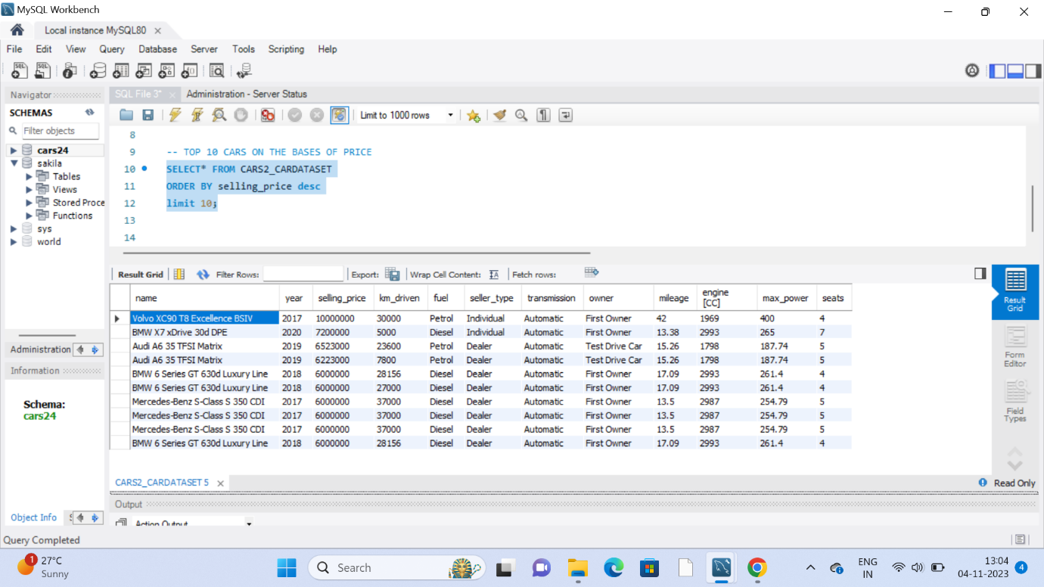

Comments:- dynamics, consumer preferences, and overall industry trends.

**Insight number3:-Top 10 least expensive cars on the bases of price**

SELECT* FROM CARS2_CARDATASET

ORDER BY selling_price asc

limit 10;

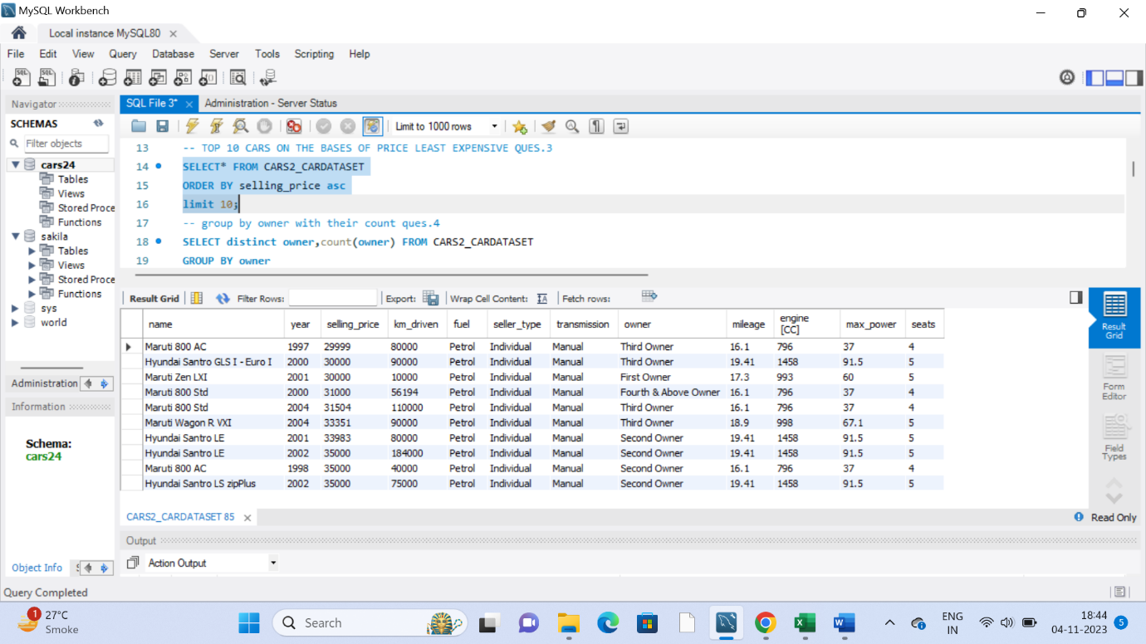

**Insight number 4:-Find the owner type and their count**

SELECT distinct owner,count(owner) FROM CARS2_CARDATASET

GROUP BY owner

order by owner;

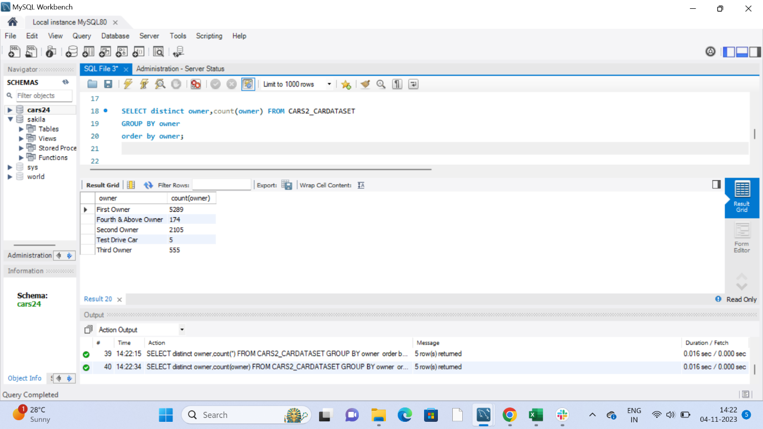

**Insight number 5:- count of each seller type**

SELECT distinct seller_type,count(*) FROM CARS2_CARDATASET

GROUP BY seller_type ;

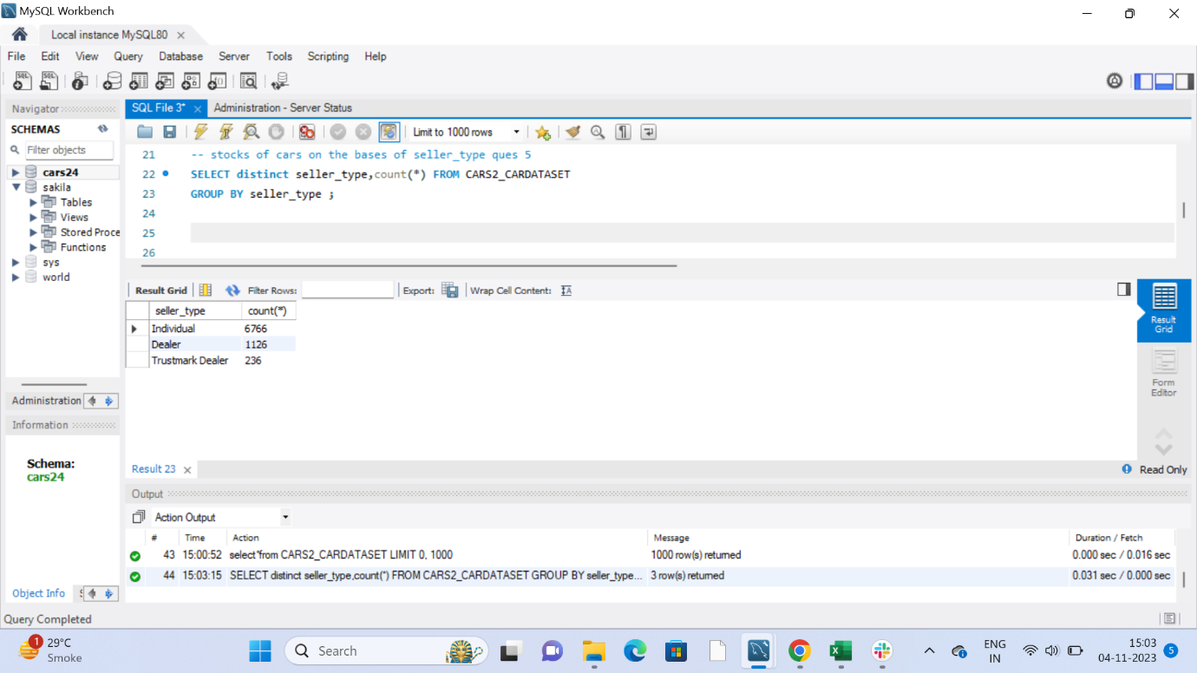

Comments:- Tracking the count of Seller type over time allows businesses to evaluate the success of their sales efforts.

**Insight number 6:- number of cars which price greater than 5000000**

select count(selling_price)from CARS2_CARDATASET

where selling_price>="5000000"

order by selling_price desc;

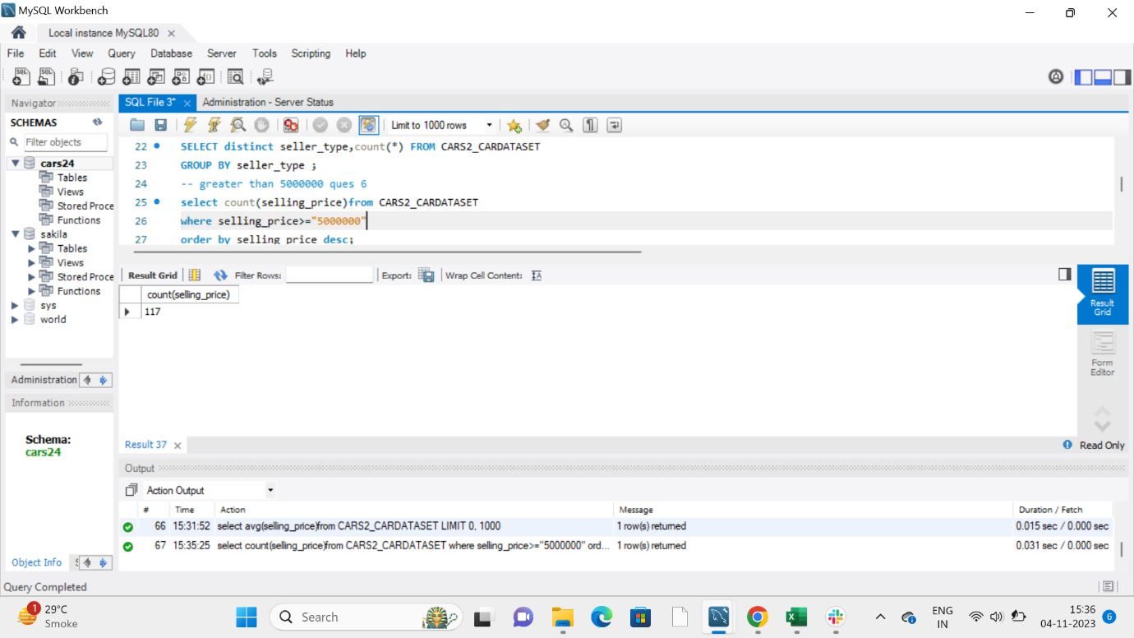

Comments:- valuable for businesses targeting affluent customers and Revenue Assessments

**Insight number 7 :-average of selling price**

select avg(selling_price)from CARS2_CARDATASET;

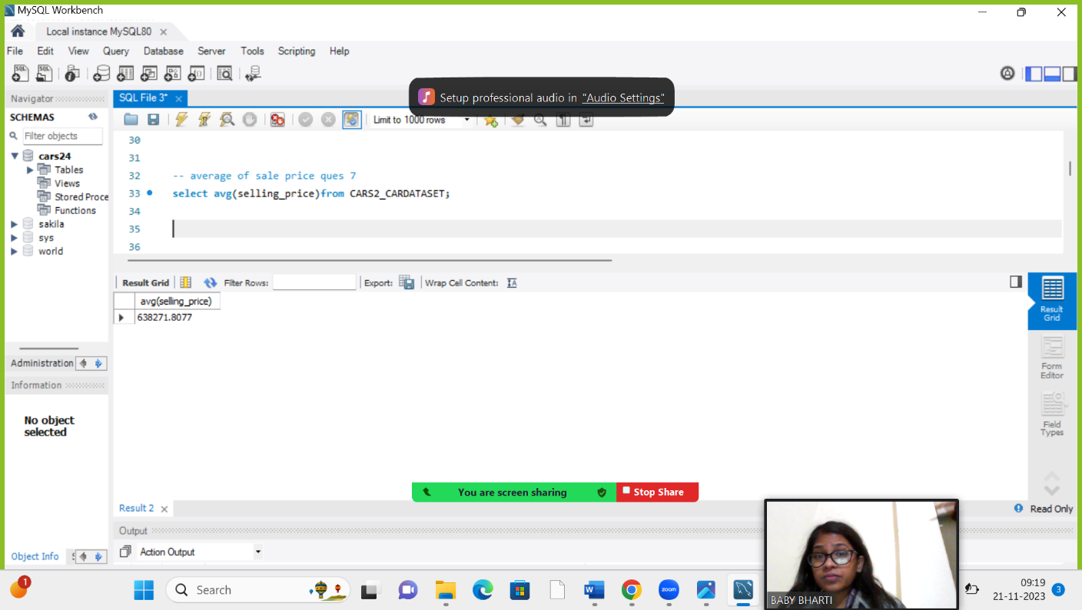

**Comments:-** overall financial planning for sustainable and profitable operations.

**Insight number 8:-Top 5 cars with maximum mileage Cars**

select name,mileage from CARS2_CARDATASET

order by mileage desc

limit 5;

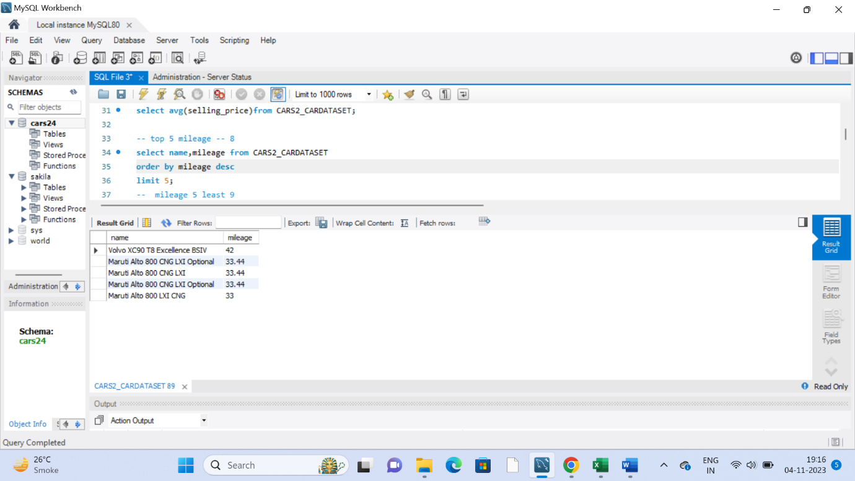

**Insight number 9:- :- 5 cars with least mileage**

select name, mileage from CARS2_CARDATASET

order by mileage asc

limit 10;

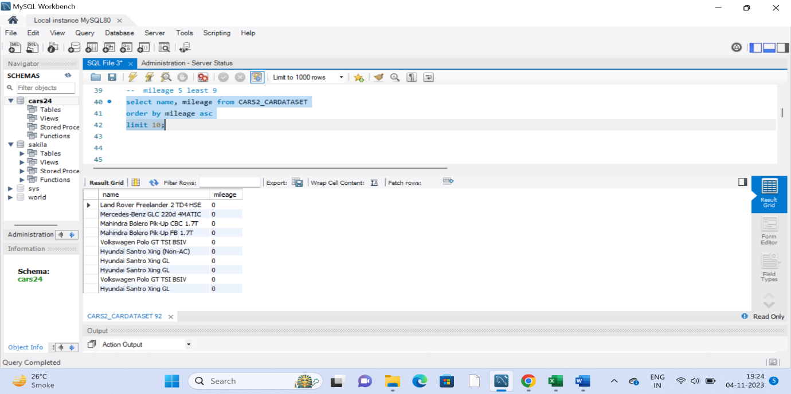

Comments:- It addresses considerations related to cost savings, environmental impact, market trends and consumer preferences.

**Insight number 10:- number of cars with 5 seaters**

select count(seats) from CARS2_CARDATASET

where seats ="5";

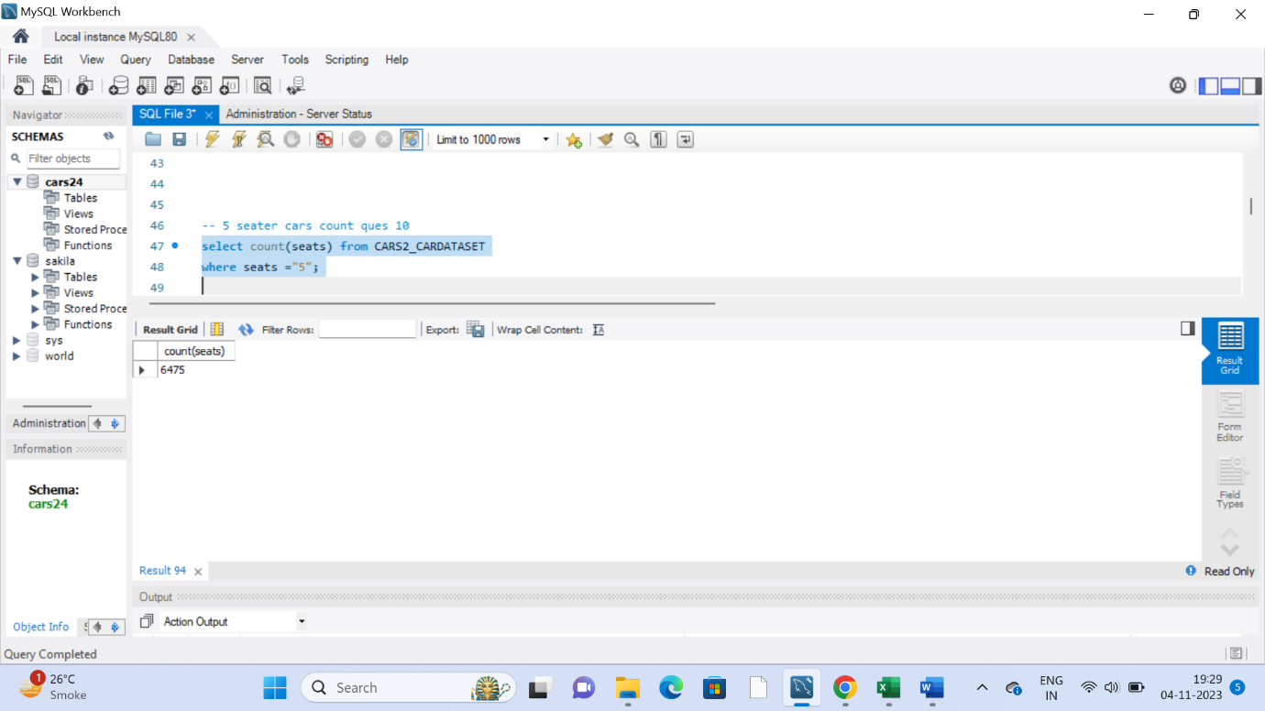

**Insight number 11:- number of cars with 7 seaters**

select count(seats) from CARS2_CARDATASET

where seats ="7";

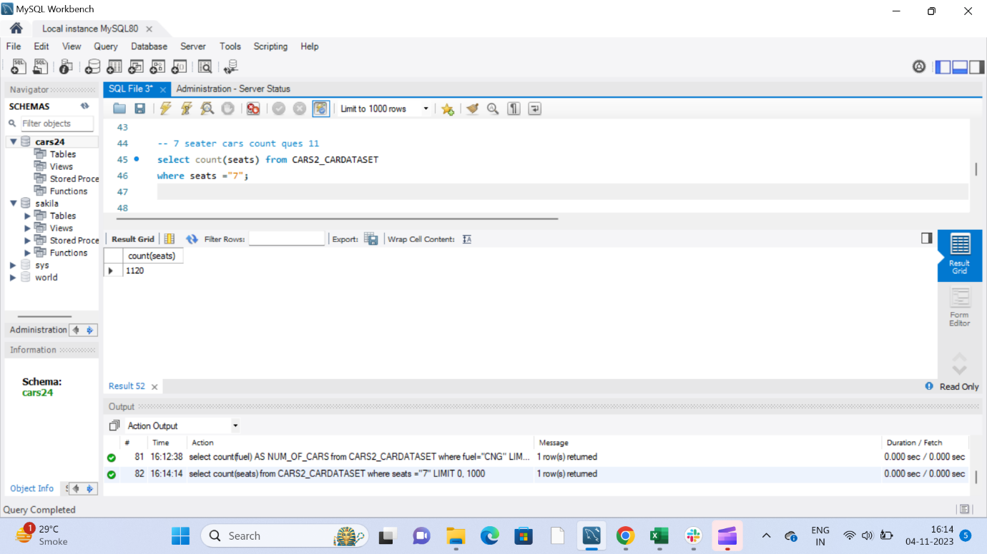

Comments:-5 Seaters car count =6475

7 seaters car count =1120. (5 seaters car is in more in demand)

**Insight number 12:-Number of cars which run by CNG**

select count(fuel) AS NUM_OF_CARS from CARS2_CARDATASET

where fuel="CNG";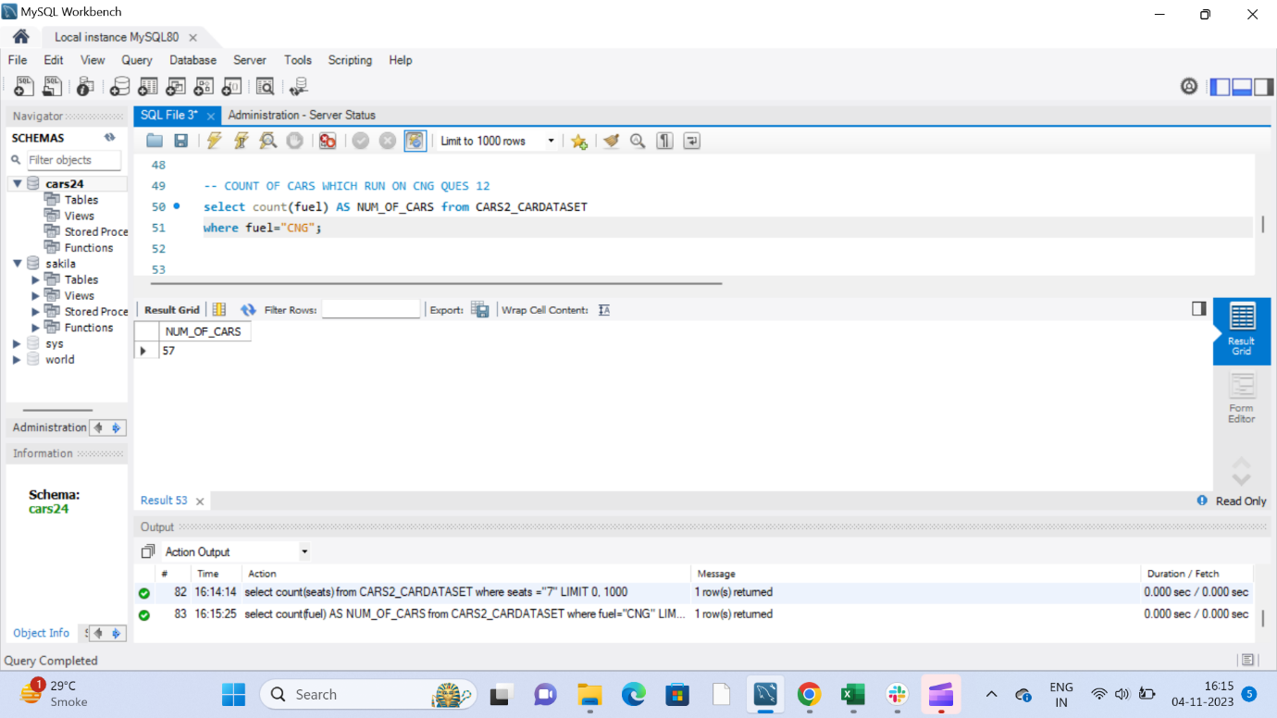

**Insight number 13:- Number of cars which run by petrol**

select count(fuel) AS NUM_OF_CARS from CARS2_CARDATASET

where fuel="petrol";

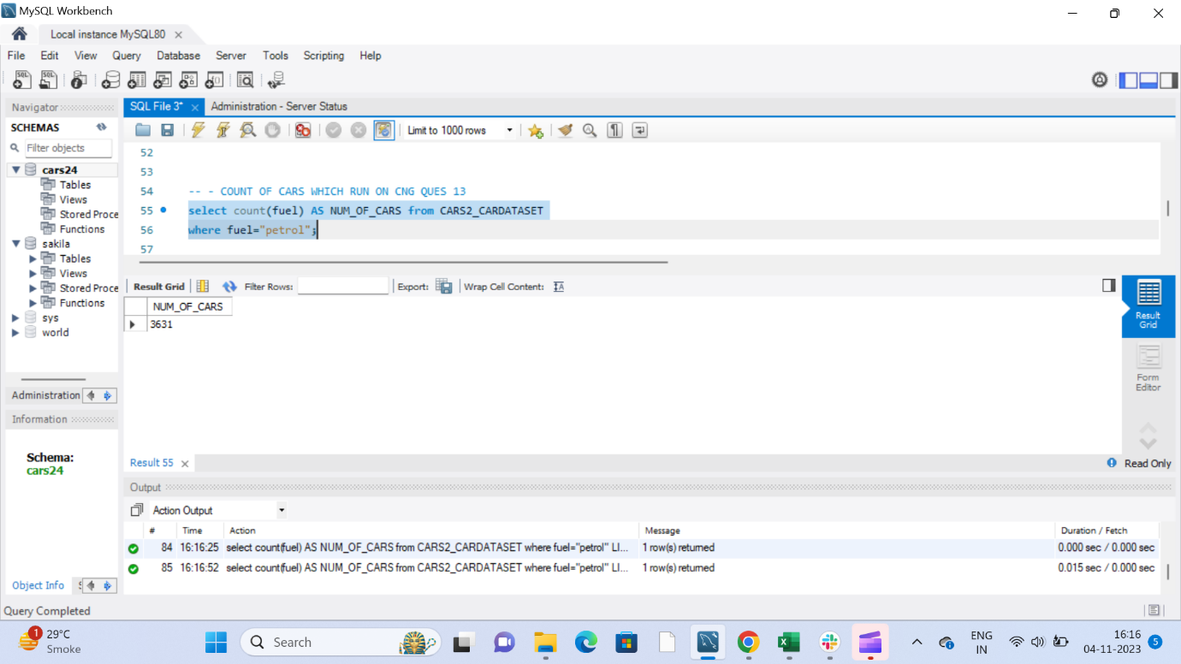

**Insight number 14:- :- Number of cars which run by diesel**

select count(fuel) AS NUM_OF_CARS from CARS2_CARDATASET

where fuel="diesel";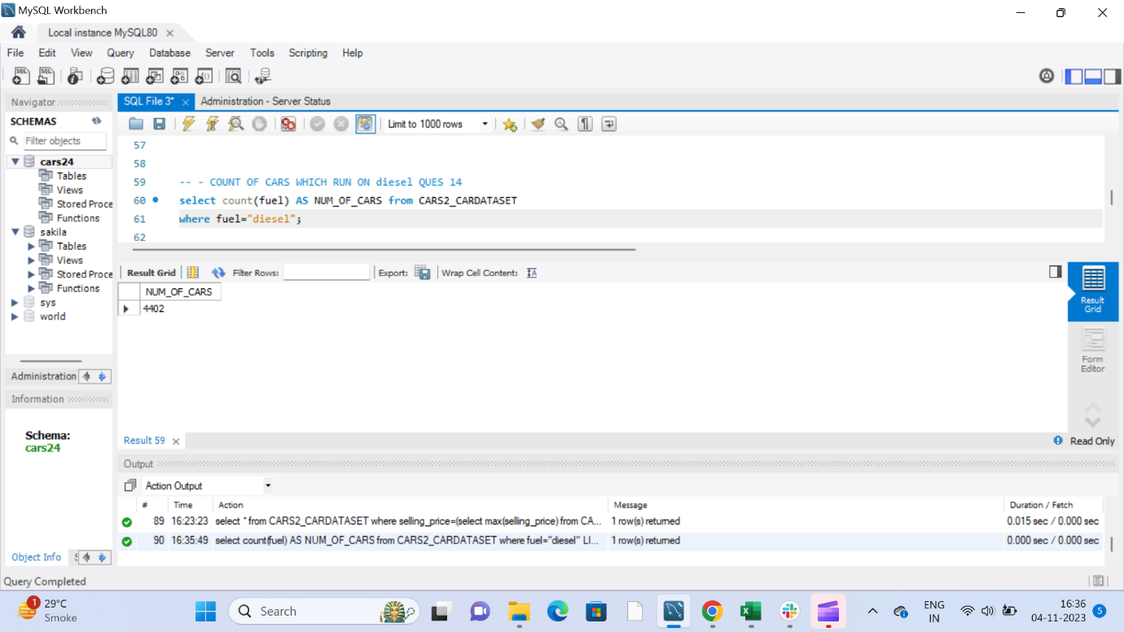

Comments:-Car which run on “CNG”=57

Car which run on “petrol”=3631

Car which run on “diesel”=4402( Car Which run on diesel is more in demand,1.long run,2.cheaper)

**Insight number 15:-Most expensive Car**

select max(selling_price) from

CARS2_CARDATASET;-- 1

select * from CARS2_CARDATASET

where selling_price=(select max(selling_price) from

CARS2_CARDATASET);-- 2

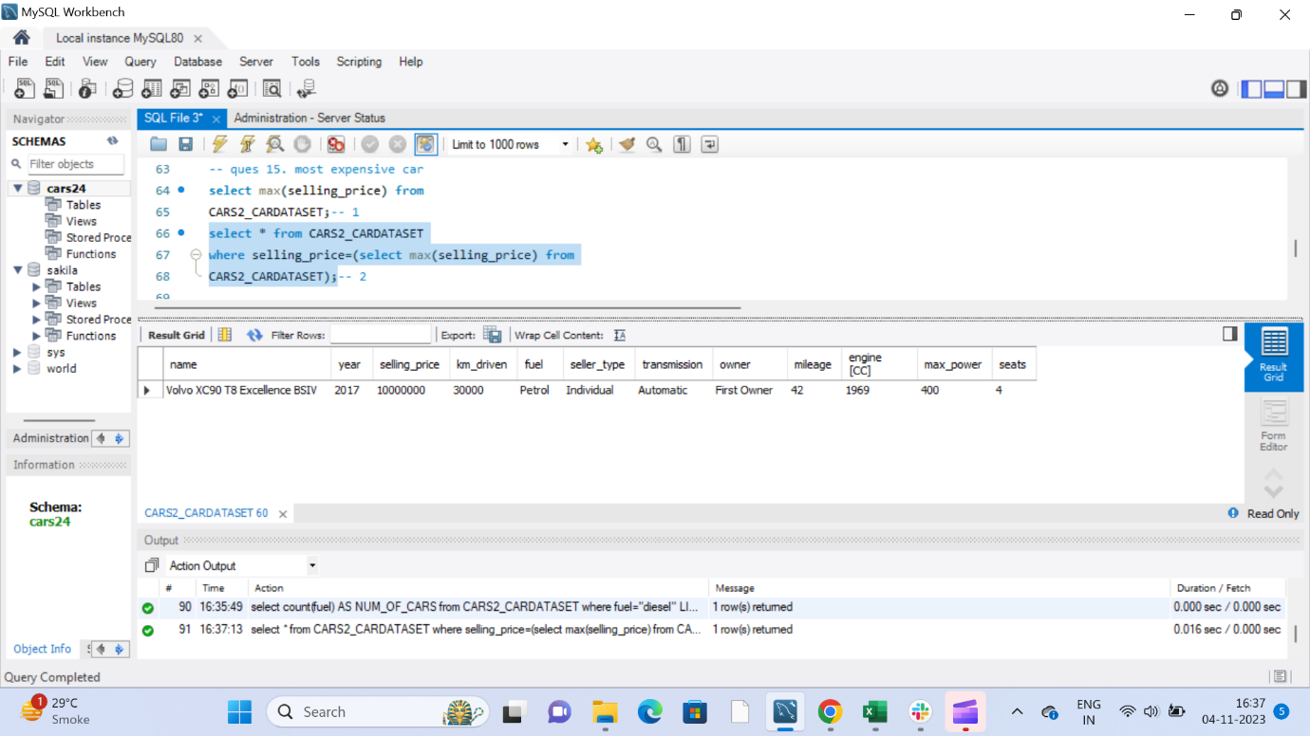

**Insight number 16:- least expensive Car**

select min(selling_price) from

CARS2_CARDATASET;-- 1

select * from CARS2_CARDATASET

where selling_price=(select min(selling_price) from

CARS2_CARDATASET);-- 2

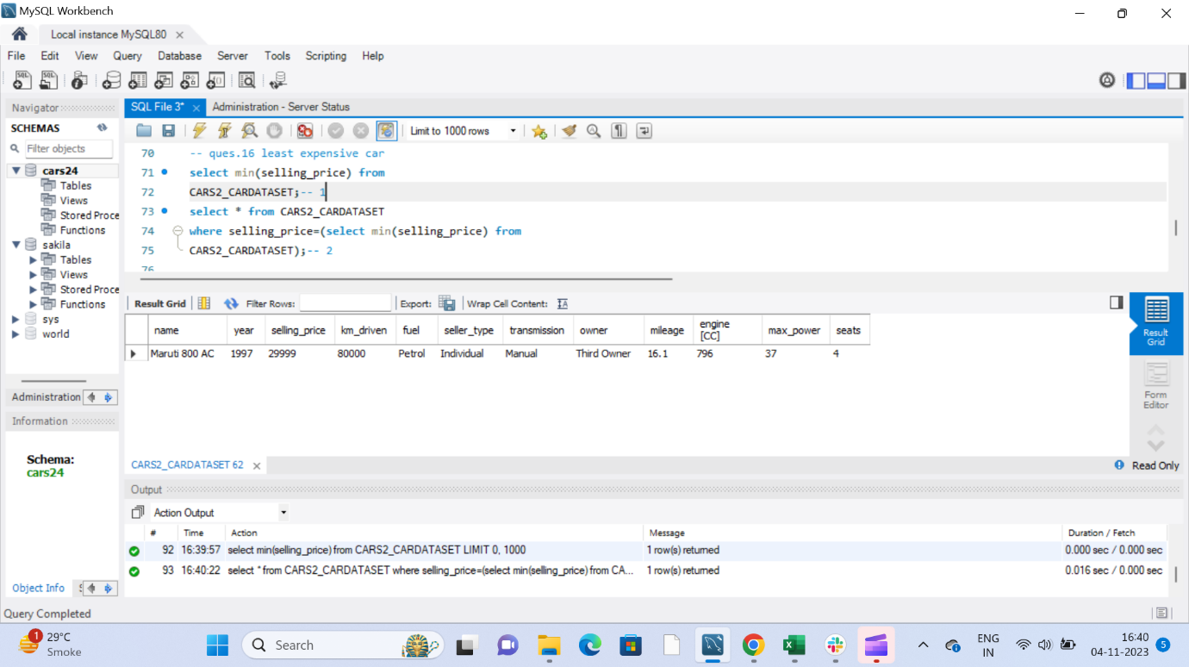

**Insight number 17:-10 years in which most car manufactured**

select year,count(year)from CARS2_CARDATASET

group by year

order by count(year) desc

limit 10;

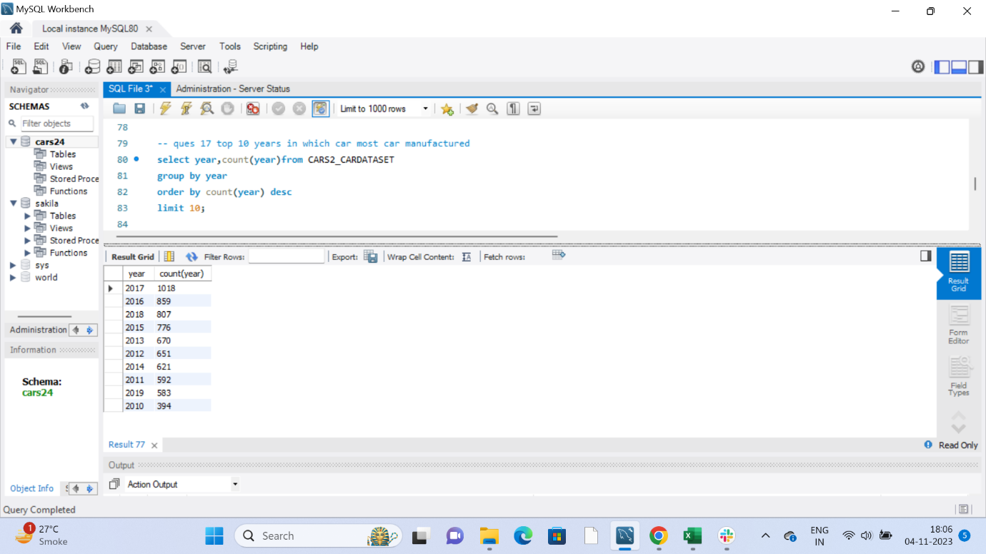

**Insight number 18:- 10 years in which least car manufactured**

select year,count(year)from CARS2_CARDATASET

group by year

order by count(year) asc

limit 10;

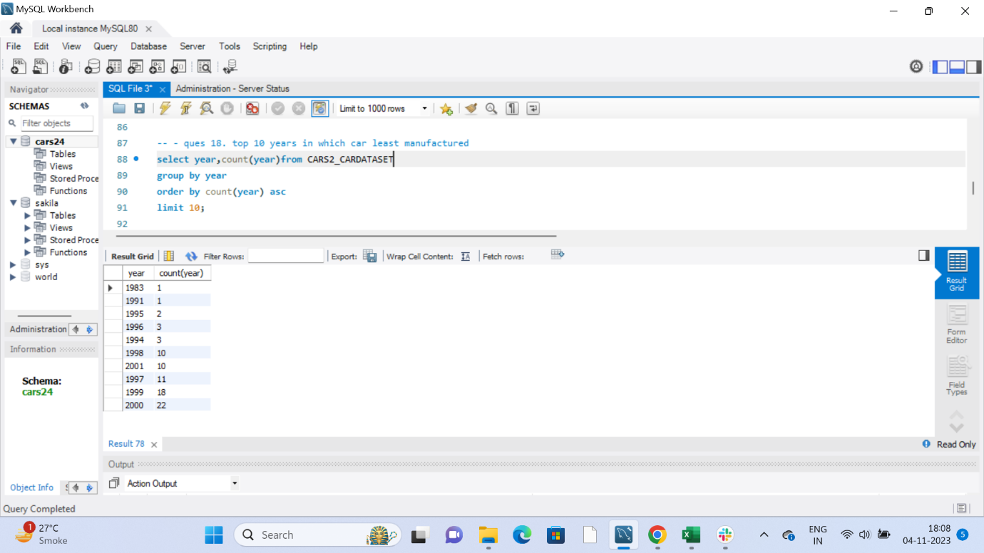

Comments: This information is valuable for understanding periods of growth, stagnation, or decline in the automotive industry.

**Insight number 19:-In which year most car manufactured.**

select year,count(year) from CARS2_CARDATASET

group by year

having count(year) = (

select max(counted) from (select count(year) as counted from CARS2_CARDATASET

group by year) as subquery );

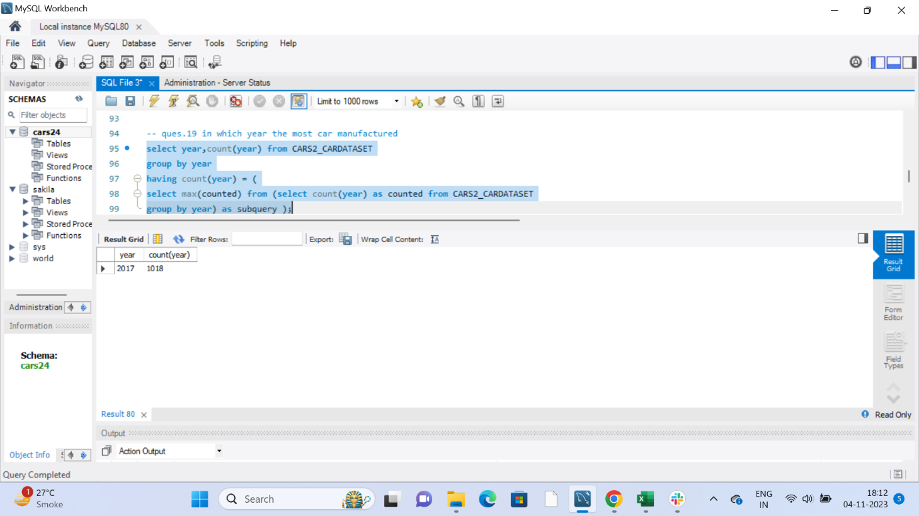

**Insight number 20:- In which year least car manufactured.**

select year,count(year) from CARS2_CARDATASET

group by year

having count(year) = (

select min(counted) from (select count(year) as counted from CARS2_CARDATASET

group by year) as subquery );

